National University Of Computer And Emerging Sciences
Discrete Structures (MT 217)
Quiz – 3
************************************************************************

Student ID: _____________ Section: ________ Date: ____________

Q#1 | Let the functions f and g be defined as follows  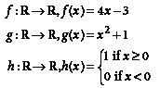  Find rules for the following functions with domain and co-domain R  - fοg  _______________________________________________________________________  _______________________________________________________________________  - h ⁻¹ (give reason if not possible)  _______________________________________________________________________  _______________________________________________________________________  _______________________________________________________________________  _______________________________________________________________________  _______________________________________________________________________ | 5
Q#2 | - Determine whether the following relation is reflexive, irreflexive, symmetric, asymmetric or transitive:  “has the same parents as” on the set of all people.  Solution:  Reflexive or Irreflexive:___________________________________________________  _______________________________________________________________________  Symmetric or Asymmetric:________________________________________________  _______________________________________________________________________  _______________________________________________________________________  Transitive or Non-Transititive: ____________________________________________  _______________________________________________________________________  _______________________________________________________________________  - State whether the above relation is “Equivalence Relations” or not.  Solution  _______________________________________________________________________ | 5
Q#3 | Show by using invariants that the following graphs are isomorphic or not.  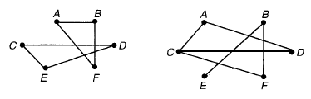  _______________________________________________________________________  _______________________________________________________________________  _______________________________________________________________________  _______________________________________________________________________  _______________________________________________________________________  _______________________________________________________________________  _______________________________________________________________________  _______________________________________________________________________  _______________________________________________________________________  _______________________________________________________________________ | 5
---------------------------------------------- ☺ BEST OF LUCK ☺ --------------------------------------------

